CS 255 System Design Document Template

This template lays out all the different sections that you need to complete for Project Two. Each section has guidance to prompt your thinking. You will need to continually reference the interview transcript as you work to make sure that you are addressing your client’s needs. There is no required length for the final document. Instead the goal is to complete each section based on what your client’s needs are. Remove this note when you are finished, and replace all bracketed text with the relevant information.

UML Diagrams

UML Use Case Diagram
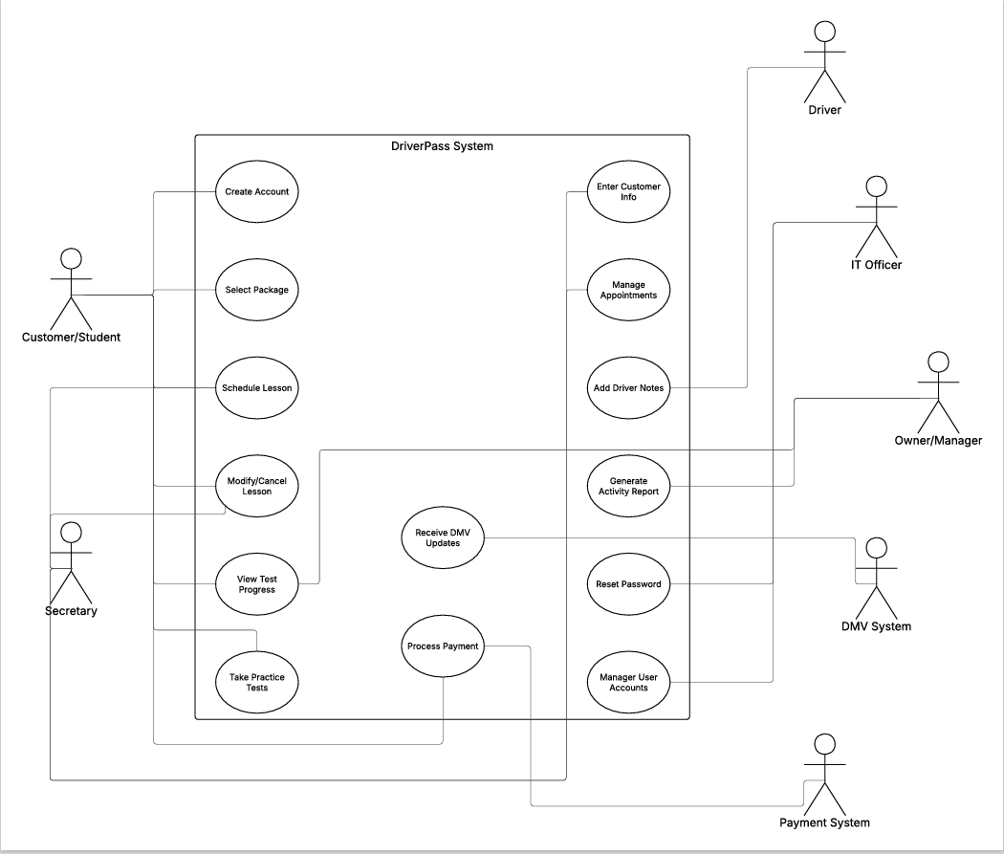

UML Activity Diagrams
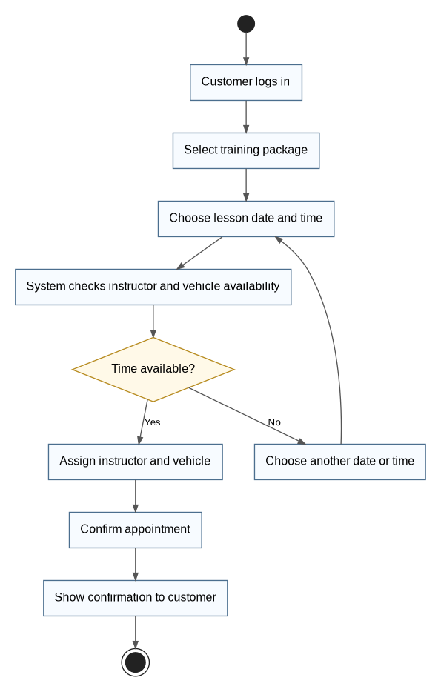
Activity diagram for scheduling a driving lesson.
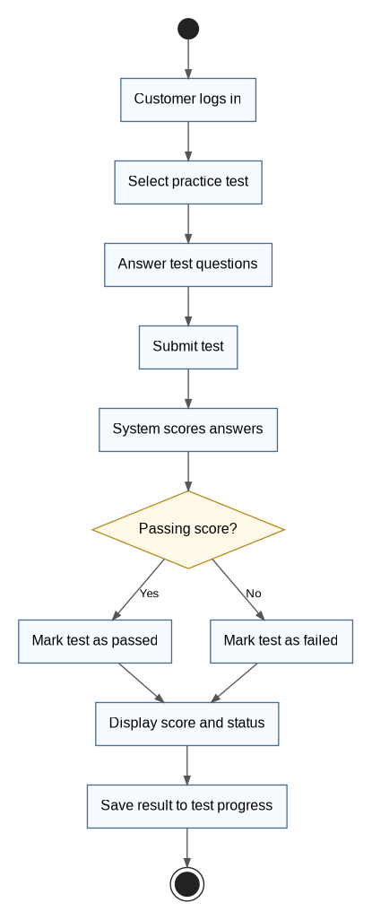
Activity diagram for completing a practice test.

UML Sequence Diagram
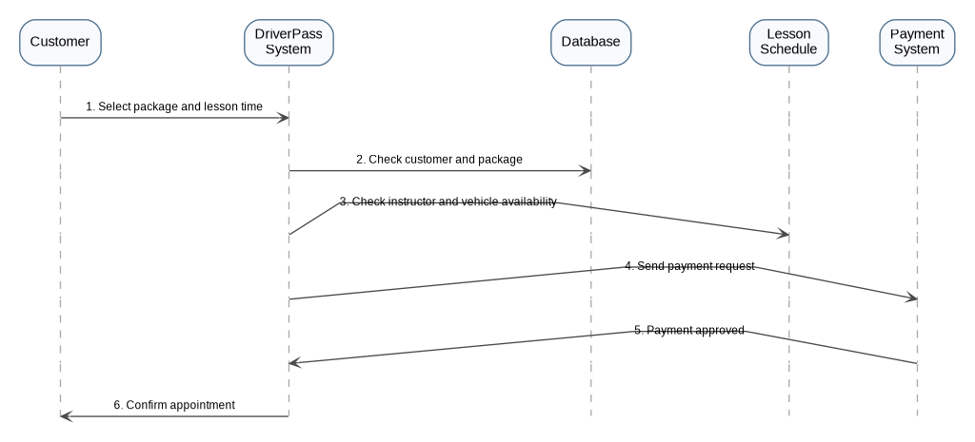
Sequence diagram showing how a lesson appointment is scheduled.

UML Class Diagram
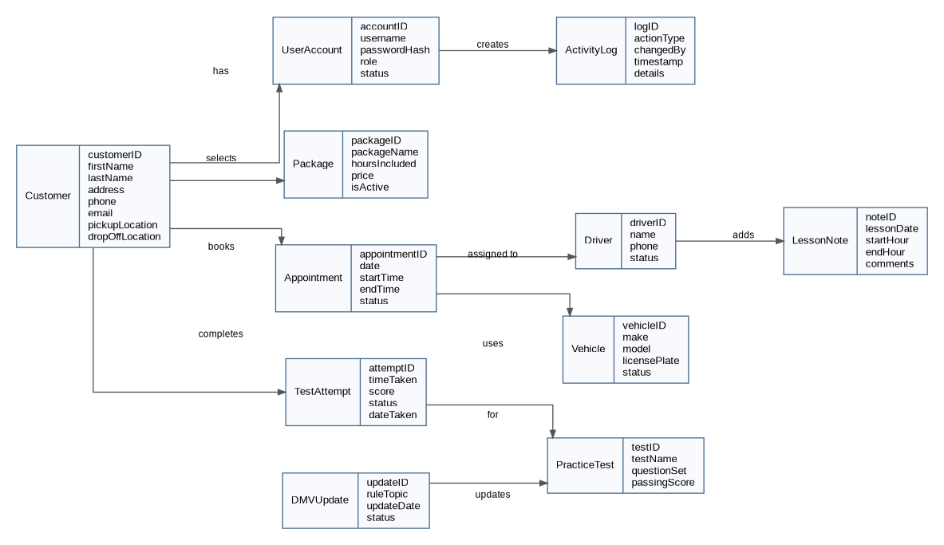
Class diagram showing the major DriverPass data classes and relationships.

Technical Requirements
- The DriverPass system should be a cloud-based web application that can be accessed through the internet. This will allow customers, employees, and management to use the system from different locations and devices. The system needs to support online practice tests, lesson scheduling, account management, reporting, and other services offered by DriverPass.
Hardware Requirements
- A cloud server is needed to host the DriverPass application.
- A database server is needed to store customer information, appointments, lesson records, test scores, and package information.
- Employees should have access to computers or laptops to manage customer accounts and appointments.
- Customers should be able to use a desktop computer, laptop, tablet, or smartphone to access the system.
- A reliable internet connection is needed so the system can be accessed without interruptions.
Software Requirements
- The system should work on common web browsers such as Google Chrome, Microsoft Edge, Safari, and Firefox.
- A database management system will be needed to organize and store customer records, appointments, and test results.
- The system should include a secure payment feature so customers can purchase training packages online.
- Reporting tools should be available so management can review business activity and customer progress.
- Password recovery and account management features should be included for both customers and employees.
Tools and Modeling Requirements
- Lucidchart can be used to create UML diagrams and communicate the system design.
- Version control software should be used so developers can track updates and changes during development.

